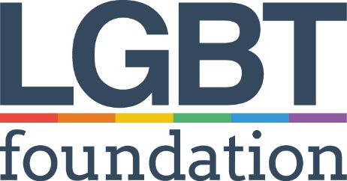 | LGBT Foundation  Application Form  Part 2

Position Applied For: Chief Executive’s Business Manager

Please complete all sections of the form in black ink or type directly into the boxes. Application forms that are not completed in full will be automatically rejected. CV’s will not be accepted.

Applications must be returned by email: recruitment@lgbt.foundation

Closing date and time is 9am on Tuesday, 6th December 2022

Interviews will take place via Video Conferencing / or in Person in Manchester – Date to be confirmed

If you require this form or any of the accompanying information in large print, please contact Simon Baker on 0345 3 30 30 30.

The lawful condition for processing this data under GDPR is ‘fulfilment of contract’.
LGBT Foundation will use this information to shortlist during and as part of the application process.
If successful, we will add you to payroll and to our pension provider, as well as our own internal HR system. We will not share this information with anyone else for any other purposes. We use authorised third parties to help us process our data who are also GDPR compliant.

Current Experience

Please complete this section, listing details of your current employer and the duties you perform in your current role.

Current Employer
Employer’s Address
Position Held
Date Employed
Duties and Responsibilities

Reason for leaving

Previous employment

Please include paid or unpaid work and account for any gaps. If you need more space, please continue on a separate sheet clearly stating the section of the form, your name and the position you are applying for.

Name & Address of Organisation | Length of Service | Brief description of duties and responsibilities (including reason for leaving)

Experience, skills, abilities and knowledge

The first stage of the application is answering 3 questions based upon the organisation’s values and your work experiences and skills.

You can choose to answer these using either:
- Video file submission
- Audio file submission
- Written submission

Video or Audio Submissions
Video/Audio file(s)can be attached to the main email OR if the files are too big we suggest using a file transfer linking service such as WeTransfer and email submissions together to recruitment@lgbt.foundation using the same email that you send this application to.
You can answer all the questions in one file if you wish.
Click here on how to use WeTransfer.

- Outline what your methodology would be to ensure all the responsibilities of the role are fulfilled?
Submission Type (choose 1) - 2 Minutes (or 260 words) or less
☐ Video (File Name Q1) ☐ Audio (File Name Q1) ☐ Written (next page)

- Explain how you use your interpersonal skills to ensure smooth collaborative working between colleagues and external partners?
Submission Type (choose 1) - 2 Minutes (or 260 words) or less
☐ Video (File Name Q2) ☐ Audio (File Name Q2) ☐ Written (next page)

- Tell us about what drives your commitment to supporting LGBTQ+ communities?
Submission Type (choose 1) - 2 Minutes (or 260 words) or less
☐ Video (File Name Q3) ☐ Audio (File Name Q3) ☐ Written (next page)

Written Submission

Question 1 Submission

Question 2 Submission

Question 3 Submission

LGBT Foundation is part of the Disability Confident scheme and is an Investors in People accredited organisation. If you prove to us that you meet all of our essential criteria, you will be guaranteed an interview.

Do you consider yourself to be disabled?

Yes No

If yes, please note here any arrangements which would need to be made if you are called for interview.

