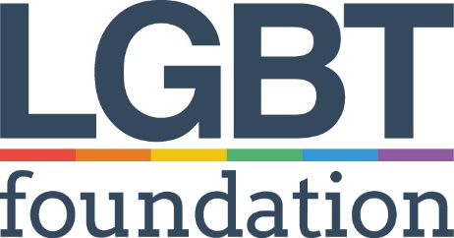  Position Applied For: | LGBT Foundation  Application Form - Part 2  Director of Operations

Please complete all sections of the form in black ink or type directly into the boxes (the boxes will expand as you type into them). Application forms that are not completed in full will be automatically rejected. CV’s will not be accepted.

Applications should be returned to:

EMAIL: recruitment@lgbt.foundation

The closing date for return of completed applications, including a completed equal opportunities monitoring form (available from www.lgbt.foundation/jobs) if one is not included in your application pack): 9am on Monday, 18th July 2022

Interviews will take place on Wednesday, 27th July 2022 at LGBT Foundation.

The lawful condition for processing this data under GDPR is ‘fulfilment of contract’.
LGBT Foundation will use this information to shortlist during and as part of the application process.
If successful, we will add you to payroll and to our pension provider, as well as our own internal HR system. We will not share this information with anyone else for any other purposes. We use authorised third parties to help us process our data who are also GDPR compliant.

Current Experience

Please complete this section, listing details of your current employer and the duties you perform in your current role.

Current Employer
Employer’s Address
Position Held
Date Employed
Duties and Responsibilities

Reason for leaving

Previous employment

Please include paid or unpaid work and account for any gaps. If you need more space, please continue on a separate sheet clearly stating the section of the form, your name and the position you are applying for.

Name & Address of Organisation | Length of Service | Brief description of duties and responsibilities (including reason for leaving)

Experience, skills, abilities and knowledge

The first stage of the application is answering four questions based upon the organisation’s values and your knowledge.

You can choose to answer these using video OR audio format submissions (nothing fancy, just using your phone is fine).

If you have a particular reason as to why you cannot submit in this format and would prefer to use a written response, please type your response using 260 words or less per question onto a separate page at the end of this application.

Video/Audio file(s)can be attached to the main email OR if the files are too big we suggest using a file transfer linking service such as WeTransfer and email BOTH submissions together to recruitment@lgbt.foundation using the same email that you sent this application from. You can answer all four questions in one file if you wish.

Add “Director of Operations – Your Name” to the message
Click here on how to use WeTransfer.

- Why do you want to work for LGBT Foundation in this role?
Submission Type (choose 1) - 2 Minutes or less
☐ Video (File Name Q2) ☐ Audio (File Name Q2)

- What leadership skills do you bring to this role?
Submission Type (choose 1) - 2 Minutes or less
☐ Video (File Name Q3) ☐ Audio (File Name Q3)

- How do you apply an intersectional lens to your work?
Submission Type (choose 1) - 2 Minutes or less
☐ Video (File Name Q4) ☐ Audio (File Name Q4)

- Tell us about your skills in leading strategic and business planning processes?
Submission Type (choose 1) - 2 Minutes or less
☐ Video (File Name Q5) ☐ Audio (File Name Q5)

LGBT Foundation is part of the Disability Confident scheme and is an Investors in People accredited organisation. If you prove to us that you meet all of our essential criteria, you will be guaranteed an interview.

Do you consider yourself to be disabled?

Yes No

If yes, please note here any arrangements which would need to be made if you are called for interview.

