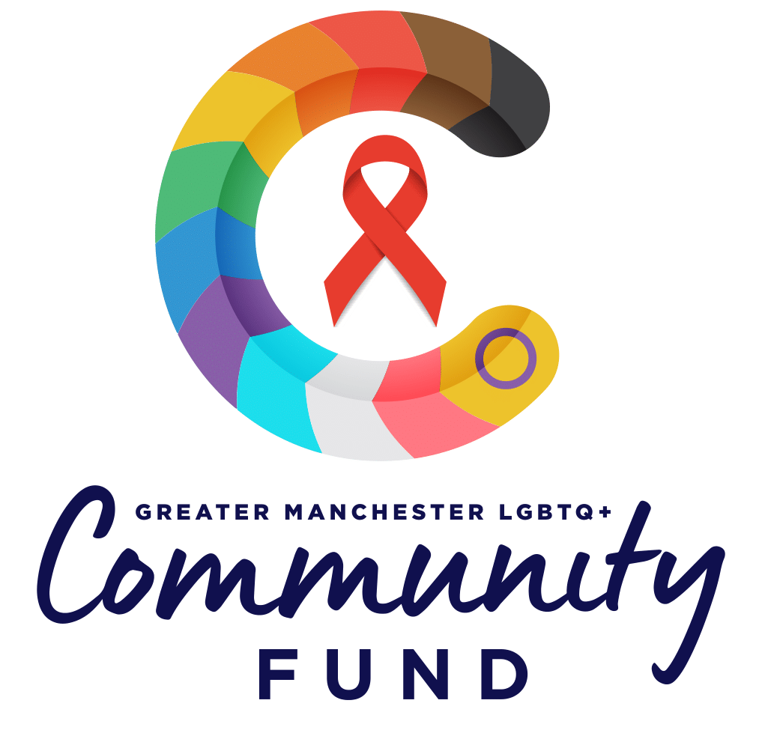

**Greater Manchester LGBTQ+ Community Fund**

**Programme Summary**

**September 2021**

**The purpose of the Greater Manchester LGBTQ+ Community Fund:**

The purpose of the fund is to inspire community action across Greater Manchester that:

* promotes inclusion for LGBTQ+ people and communities.

and/or

* raises awareness of HIV.

**Grant award**

The maximum grant award from the Greater Manchester LGBTQ+ Community Fund is £1,000. Applicants can apply for any value up to and including, £1,000.

**Eligibility Criteria**

To be eligible to apply for funding from the Greater Manchester LGBTQ+ Community Fund, all of the following core criteria must be met:

* **The application must be from a not-for-profit entity group or organisation based in Greater Manchester**.
* **The application must be for delivery of an LGBTQ+ or HIV specific project or activity**.
* **Income in the last 12-months must be under £100,000.**
* **The group or organisation that is applying must have a bank account that has 2 or more signatories from people not related or living at the same address.**
* **Any monitoring from previous funding from the Greater Manchester LGBTQ+ Community Fund must be received.**

Any application not meeting any element of this core criteria will not be assessed by the panel.

**Considerations for applicants**

The following are key considerations for applicants that should be covered in your application, if relevant:

* If your proposed activity involves working with children, young people or vulnerable adults, that you have the appropriate safeguarding policies and training in place.
* You will have the appropriate insurance cover in place for the delivery of your activities.
* You have appropriate risk management procedures in place, including working safely with Covid.
* The Greater Manchester LGBTQ+ Community Fund logo should be used in all promotion of the activities funded by the fund.

**What will be funded**

We will fund any costs associated with the delivery of a project that improves the experience of LGBTQ+ people, promotes inclusion and awareness of LGBTQ+ people, communities and the issues that impact their lives or raises awareness and educates around HIV.

The types of things that we will fund include:

* Innovative and creative projects.
* Volunteer expenses.
* Activities and events.
* Marketing, resources and printing.
* Venue hire.
* Insurances.
* Staff costs or the cost of sessional workers where relevant to the delivery of your activity.
* I.T. costs including equipment such as laptops and printers.

**What won’t be funded**

We will not fund any project that doesn’t have a direct alignment to supporting LGBTQ+ people and communities or HIV in Greater Manchester.

The types of things that we won’t fund include:

* Activities or initiatives that won’t provide demonstrable benefit to LGBTQ+ people and communities in Greater Manchester.
* Projects taking place outside of Greater Manchester.
* Anything that is a statutory responsibility of any public body.
* Activities and events that have already happened.
* Equipment that has already been purchased.
* Anything that takes place ahead of formal notification of the funding allocation.
* Private businesses or public sector organisations.

We recognise LGBTQ+ and HIV community action as political in its broadest sense and the fund will support activities that make a statement. We will not fund organisations or activities that are party political.

Where an activity, project or event is not managed by a recognised structure, an application may be accepted on behalf of such an entity by a registered structure. For example, if there’s a social group in Wigan that wishes to deliver an event for World AIDS Day, but they have no constituted body, a supporting organisation such as a local charity can submit the application on their behalf. For any such enquiries, please email [LGBTFund@ght.org.uk](mailto:LGBTFund@ght.org.uk) for clarity before making an application.

**The timeline for the Greater Manchester LGBTQ+ Community Fund:**



**Application process**

Applications must be submitted by 11:59pm on 5th October 2021. Applications submitted after that date and time will not be accepted.

All applications should be submitted using the application form template. Please don’t send the application as a PDF or image, please submit it in Microsoft Word format. Where there is an accessibility issue, a group or organisation can’t use the required format or for anyone who doesn’t have access to a computer, you can telephone 0161 274 4499 for further guidance.

**Grant Award Decision Making**

All grant award decisions will be made by an independent panel which will include:

* NHS representative.
* Manchester City Council representative.
* Village Licensed Business Association (VLBA) representative.
* A community representative.
* George House Trust trustee.
* LGBT Foundation trustee.

LGBT Foundation will lead on the appointment of the panel members. The composition of the panel will be public.

The panel will be co-chaired by the Chief Executives of George House Trust and LGBT Foundation. The panel chairs will not have a vote on grant decisions.

The panel will receive all applications in advance, together with scoring criteria. Panel members will be reminded of both the value of the grant <£1k and the intention of the fund to support grassroots community activity. Any applications that did not meet all eligibility criteria won’t be reviewed by the panel. The panel will be made aware of the reason and number of applications that did not meet eligibility criteria.

The scoring criteria followed by the panel will be consistent across all grant applications. All applications will be discussed at panel and the panel will agree whether to recommend for funding, to allocate less funding than what was applied for or to decline the grant. Where there is unanimous agreement to fund, however the total amount available is less than the planned allocation, the panel will make a decision inline with the funding priorities, the types of activity and geographic distribution across Greater Manchester.

The rationale for decisions will be agreed by the panel and fed back to individual applicants.

**Transparency**

All grant awards (amount, group/organisation and project details) will be made public through an announcement and information about the award will be publicly available.

**Greater Manchester LGBTQ+ Community Fund**

c/o

George House Trust & LGBT Foundation.

75-77 Ardwick Green North St Georges House, 215-219 Chester Road

Manchester Manchester

M12 6FX M15 4JE

Email: [LGBTFund@ght.org.uk](mailto:LGBTFund@ght.org.uk).